**Step 11: Move Data into RDS**

1. Once your stack is up and running, on your local machine, open up MySQL Workbench
2. In the Connections screen, hit the + button to add a new connection, and the Setup New Connection screen will appear

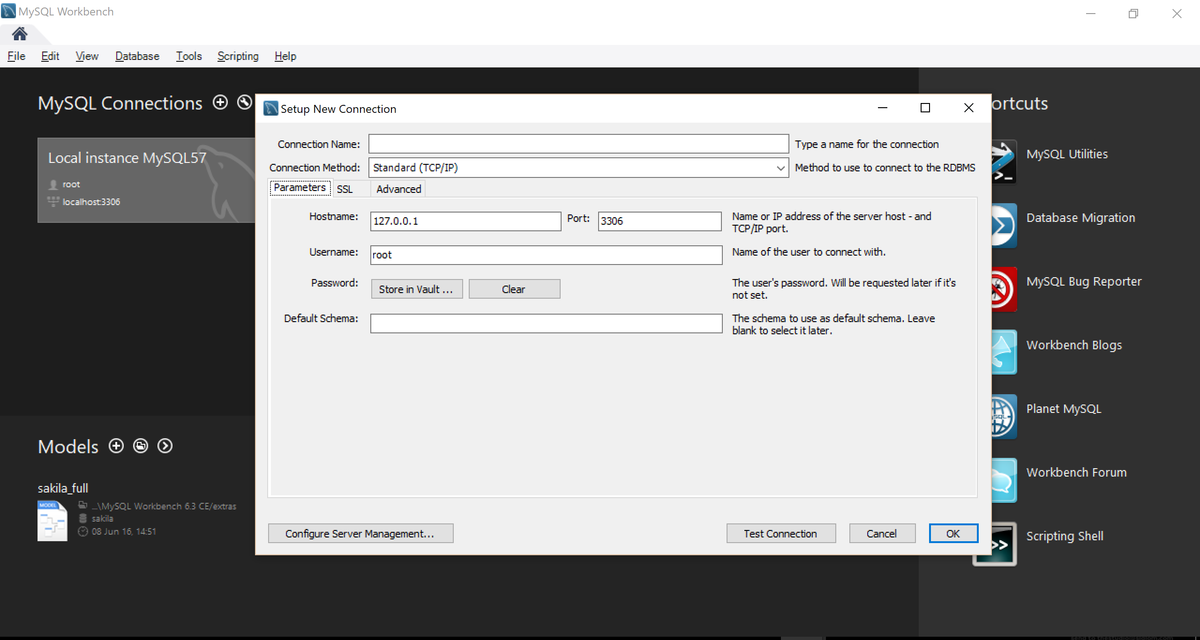

1. Give your connection a name (“My Aurora DB”, for example)
2. In the hostname, add the public endpoint of the RDS cluster that was created in step 7. You can find that in the RDS management console

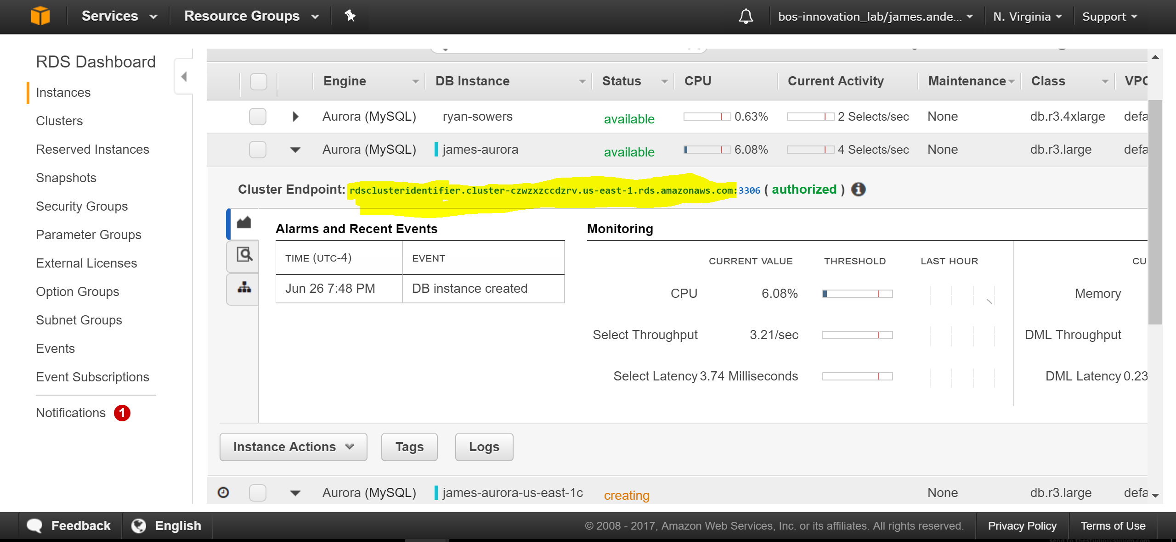

1. Change the username to the username that you set up in step 7.
2. Click on the “Store in Vault…” button, and enter the password you created in step 7.
3. Click on the “Test Connection” button, and you should receive a success message
4. Once you have the connection set up, click on “OK”, then select the connection to initiate a new session
5. In the query window, copy and paste the following DDL (Data Definition Language) script into the editor:

**CREATE TABLE DBName.Orders (**

**Row_ID INT,**

**Order_ID VARCHAR(100),**

**Order_Date DATE,**

**Ship_Date DATE,**

**Ship_Mode VARCHAR(100),**

**Customer_ID VARCHAR(100),**

**Customer_Name VARCHAR(100),**

**Segment VARCHAR(100),**

**Country VARCHAR(100),**

**City VARCHAR(100),**

**State VARCHAR(100),**

**Postal_Code VARCHAR(100),**

**Region VARCHAR(100),**

**Product_ID VARCHAR(100),**

**Category VARCHAR(100),**

**Sub_Category VARCHAR(100),**

**Product_Name VARCHAR(100),**

**Sales FLOAT,**

**Quantity FLOAT,**

**Discount FLOAT,**

**Profit FLOAT**

**);**

**CREATE TABLE DBName.Returns (**

**Returned VARCHAR(100),**

**Order_ID VARCHAR(100)**

**);**

**CREATE TABLE DBName.People (**

**Person VARCHAR(100),**

**Region VARCHAR(100)**

**);**

1. To execute all the queries, click on the lightning bolt

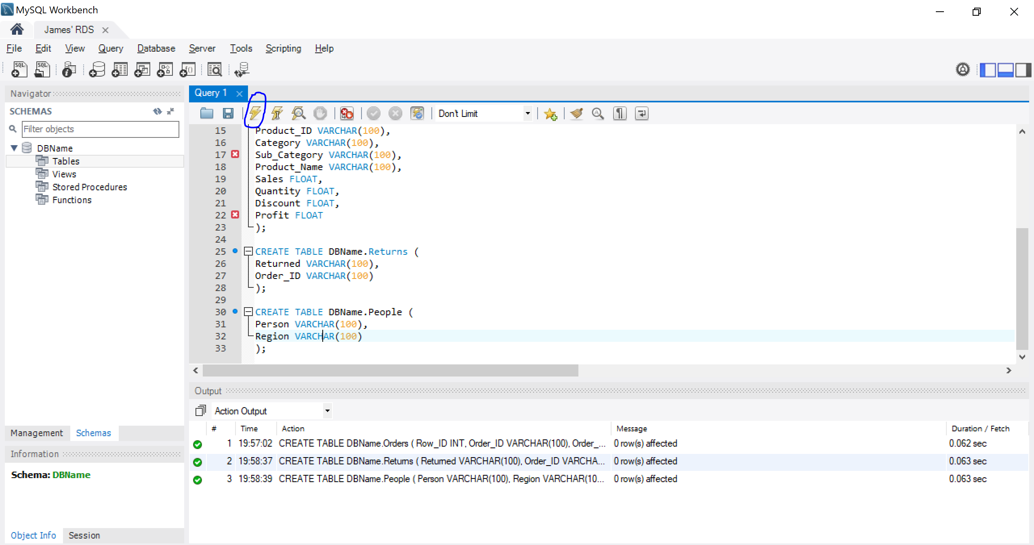

1. Before we can copy data from S3, we need to associate the IAM roles created in step 7 to our RDS Cluster. In order to do that, you must login to the Management Console, and click on RDS
2. From there, click on the “Clusters” tab on the left, and highlight the new cluster you have created.
3. Click on “Manage IAM Roles” at the top, and add both the IAM roles created in step 7 to the cluster, and click done
4. Once all the tables are created and the IAM roles have been associated, we can now copy the data from a public S3 bucket over to the database. In order to this, execute the below SQL statements:

**LOAD DATA FROM S3 's3://aws-slalom-brown-bag-sample/Orders.csv'**

**INTO TABLE DBName.Orders**

**IGNORE 1 LINES;**

**LOAD DATA FROM S3 's3://aws-slalom-brown-bag-sample/Returns.csv'**

**INTO TABLE DBName.Returns**

**IGNORE 1 LINES;**

**LOAD DATA FROM S3 's3://aws-slalom-brown-bag-sample/People.csv'**

**INTO TABLE DBName.People**

**IGNORE 1 LINES;**

1. Once these queries are finished running, the data will be in your tables for querying!

**Step 12: Create Tableau Data Source**

1. Now that you have data in RDS, you can use it to build Tableau Dashboards for your teams! In order to begin, open up Tableau Desktop on your machine
2. Once you open up Tableau Desktop, the main screen will look like below:

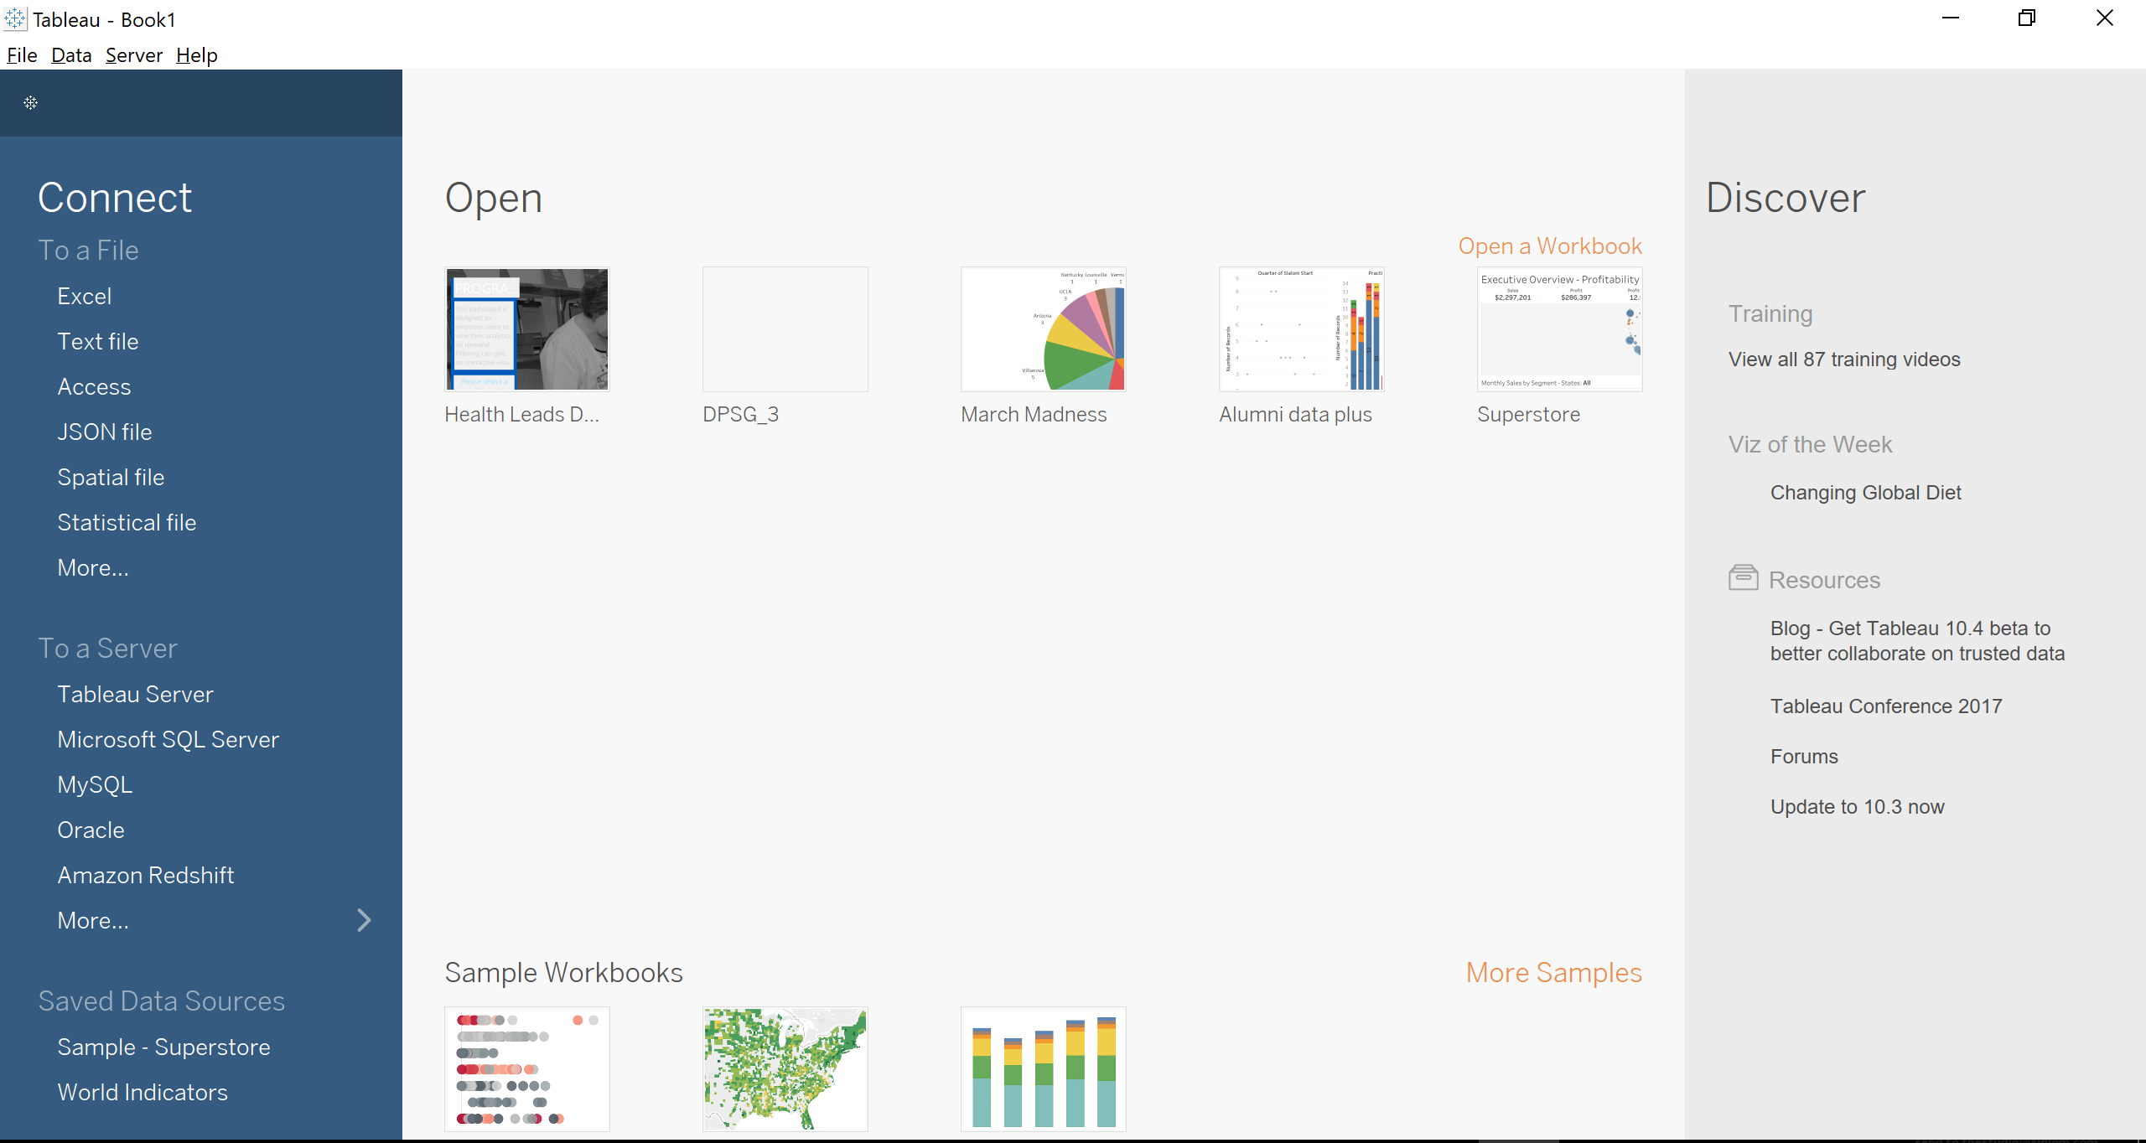

1. In order to connect to your Aurora Database, click on “More…” under the To a Server, and select the “Amazon Aurora” option
2. Using the same connection information used to set up the MySQL workbench connection, sign into the Aurora DB instance
3. Once you get to the Data Source setup window, select the DBName database on the left drop down, and the 3 tables you set up in the previous step will show up
4. First, pull in the “Orders” table to the Data Source pane. Then, add the “Returns” and “People” tables. Tableau will automatically set up the join conditions, but they will be Inner Joins. In order to change them to Left Outer Joins, simple click on the bubbles, and select the Left Join (shown below):

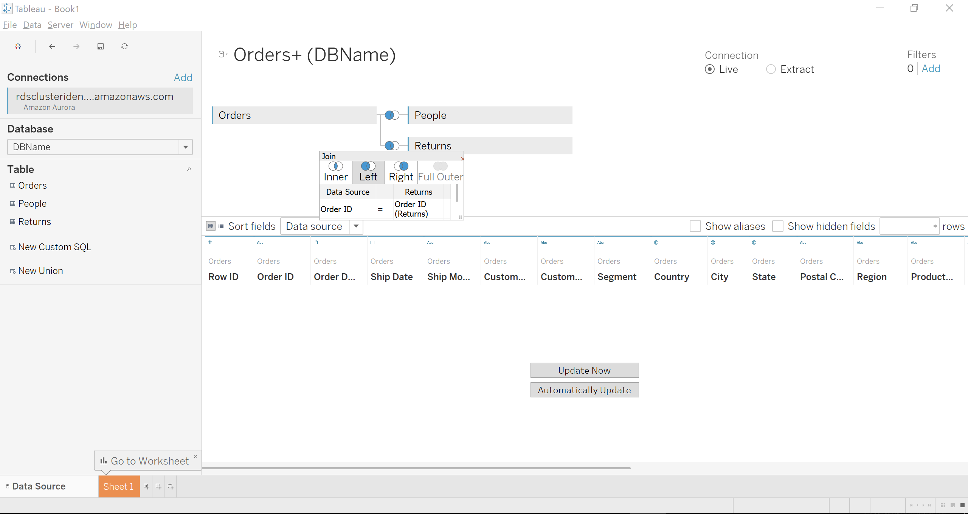

1. Once you have your data source set up, click on Sheet 1 to start visualizing!

**Step 12: Create Tableau Dashboard**

1. When you get to Sheet 1, pull the following fields into the sheet in order to create a map of the USA, with a heat map showing highest profit:
   1. Profit to “Color”
   2. Country to “Detail”
   3. State to “Detail”
   4. Under the “Show Me” heading at the top left, select the “Filled Map” option
2. If correct, the corresponding map will look like the below map:

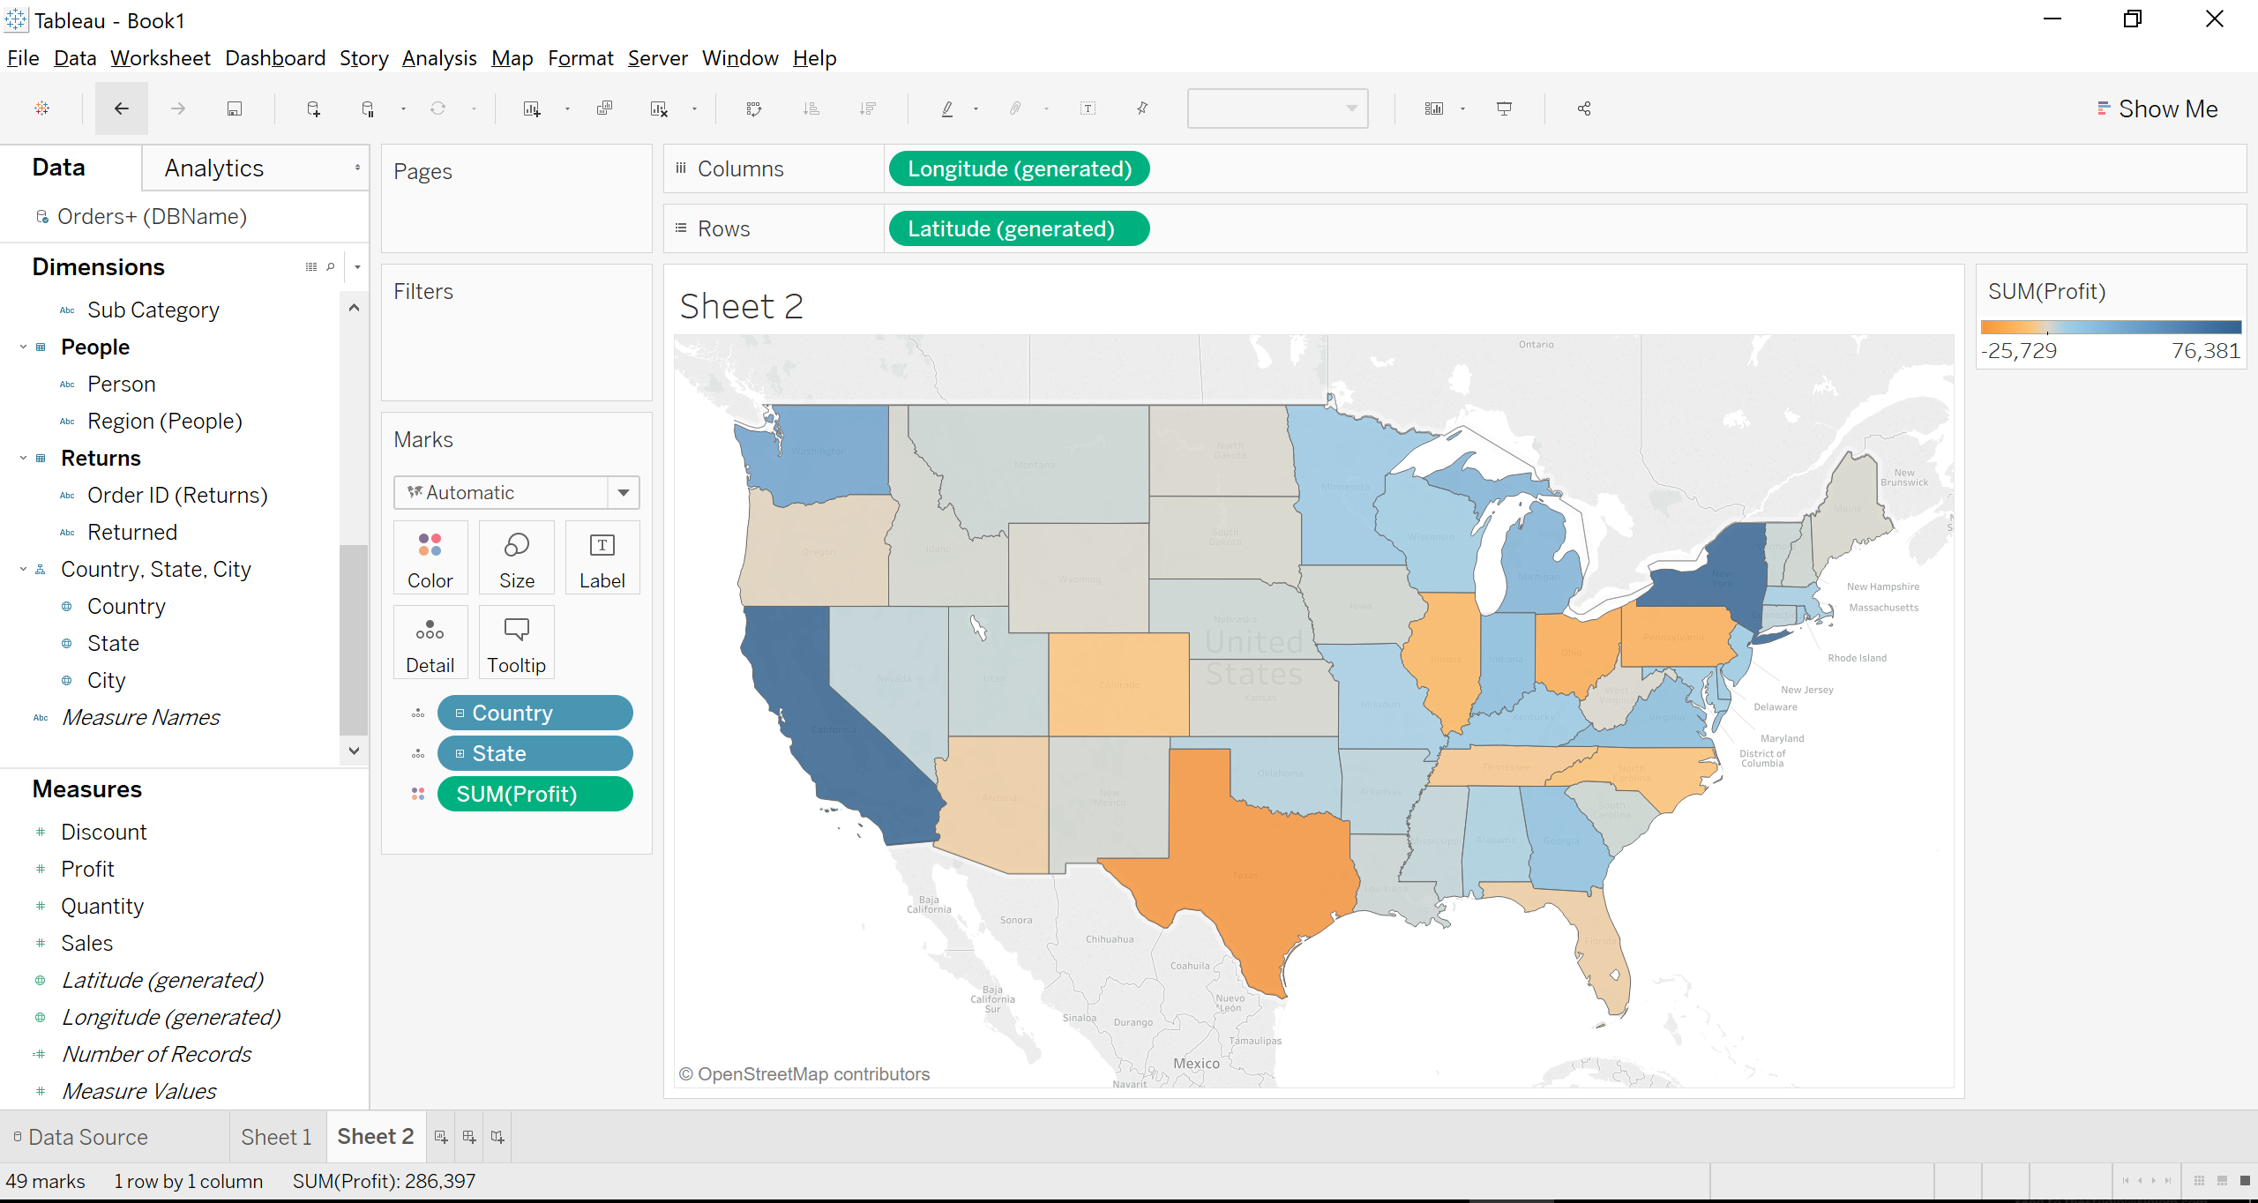

1. Once you have this map on a sheet, click on “Dashboard/New Dashboard” at the top pane
2. From the left, Drag “Sheet 1” into the Dashboard page to add the sheet to the Dashboard page.
3. Once you have your dashboard ready, you can publish it to your new Tableau Server!